**Coding challenge**

**Python**

**Name: Rohan Vinayak Chaudhari Email:**[**chaudharirohan24@gmail.com**](mailto:chaudharirohan24@gmail.com)

**Batch: Data Engineering 1**

## **Question2:** Execute Pyspark -sparksql joins & Applying Functions in a Pandas DataFrame.

**SparkSql:**

Created 2 DataFrame df1 & df2 with common column Name to perform sql operations:

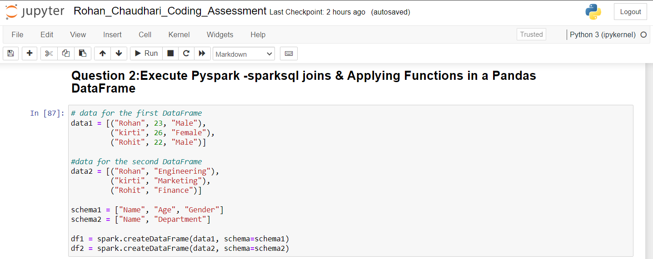

Created views To Perform SQL operations on DataFrame:

Performed Inner join with common Column Name:

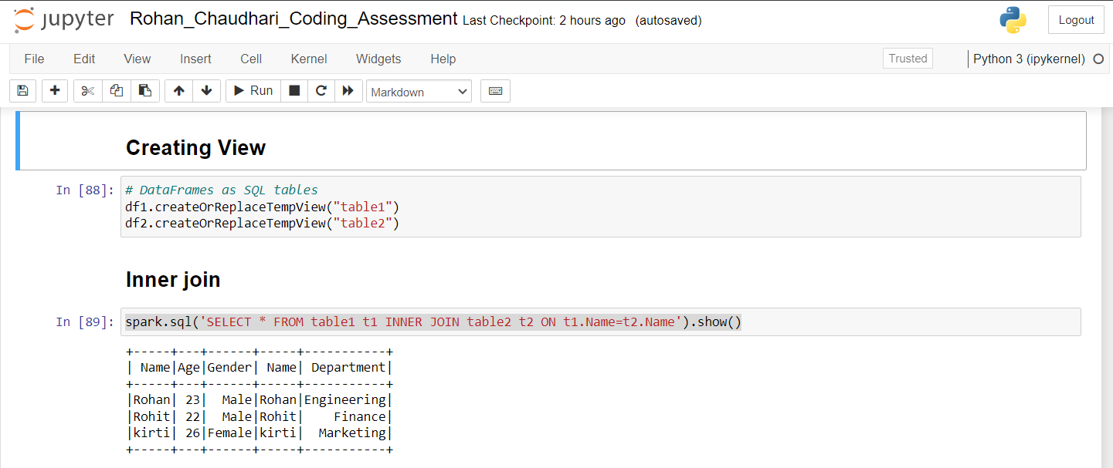

Performed Left & Right join on Both table:

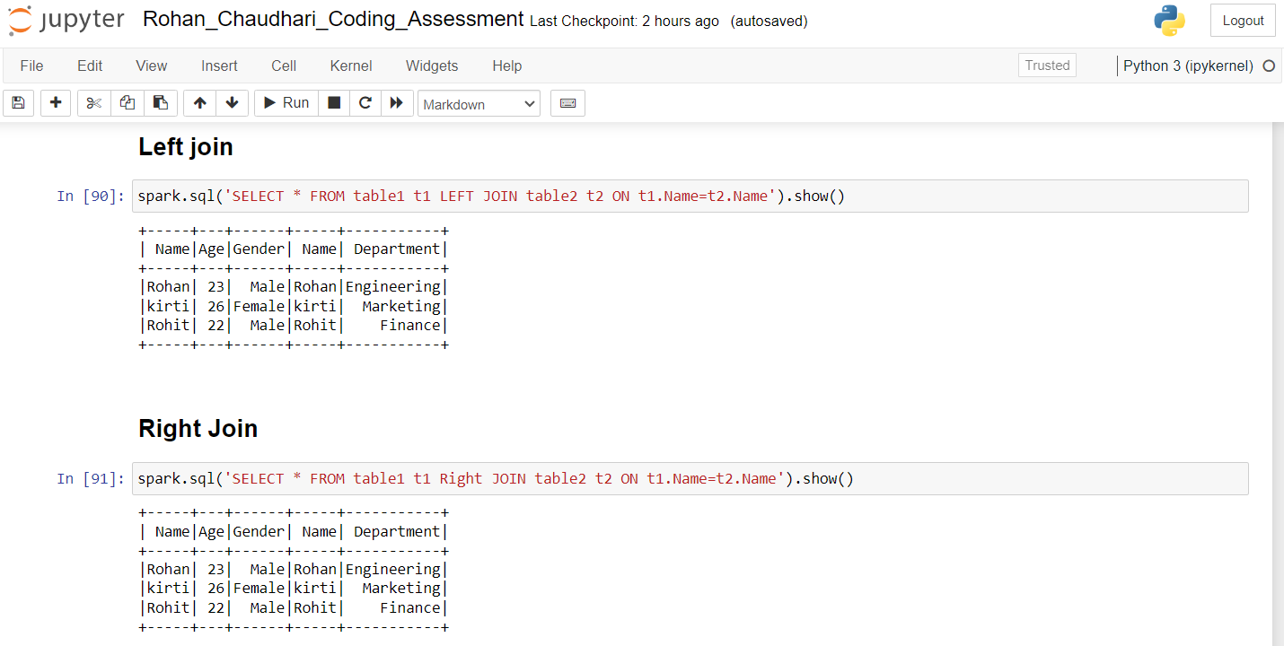

Performed Cross Join on Table 1 and table 2:

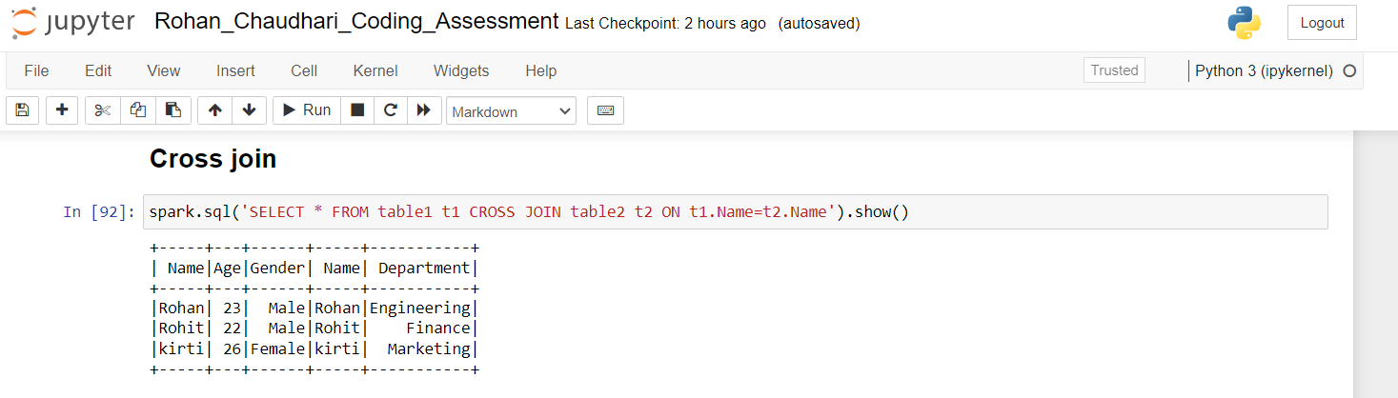

**Pandas:**

Retrieved a csv file Containing 891 rows:

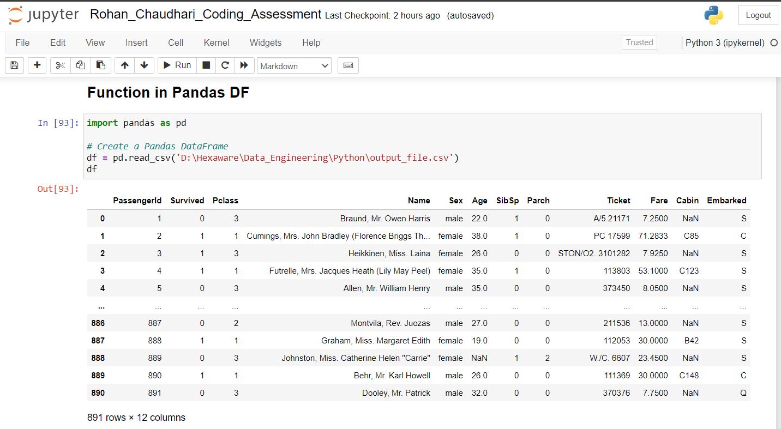

Created a function with help of Survived column where if row contains data as 1 then passenger is alive:

